

**Mobile Application & Development**

**Project Title:**

**Event Ticket Booking**

**Team:**

**Games of Codes**

**Tag line: Brace Yourself, Bugs Are Coming**

**Instructor by: Dinyal Nawaz**

**Submit Date:**

**Group Members Details:**

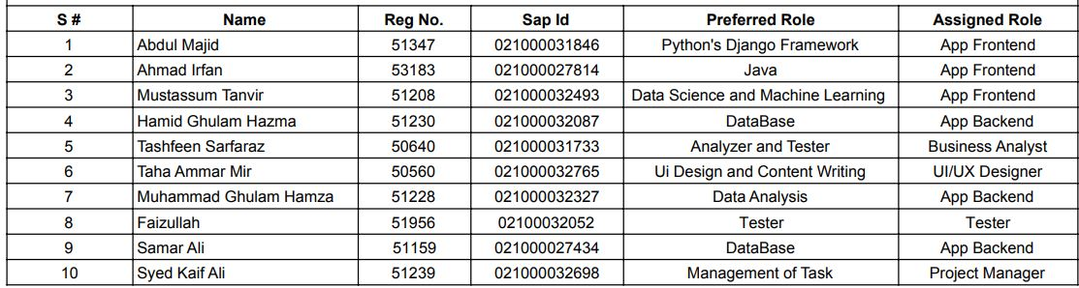

**Standard Development Life Cycle:**

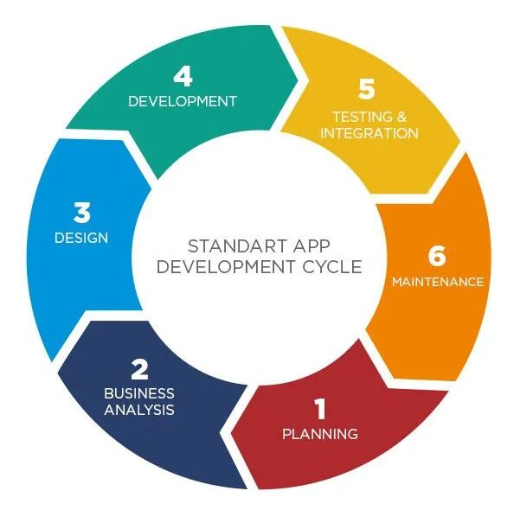

App Business Flows:

**User Registration and Profile Creation:**

Flow: Users register on the app, providing personal details and preferences.

Financial Benefit: Increased user registrations expand the user base, attracting potential advertisers and sponsors. Advertisers may pay for targeted promotions to a specific user demographic.

**Event Discovery and Selection:**

Flow: Users explore a variety of events, view details, and select preferred ones.

Financial Benefit: The more events users explore and select, the higher the likelihood of ticket purchases. Increased transactions directly contribute to revenue through ticket sales and associated fees.

**Seat Selection and Booking:**

Flow: Users choose seats using interactive maps and complete the booking process.

Financial Benefit: Efficient seat selection and booking result in increased ticket sales,generating direct revenue for the app

**Secure Payment Processing:**

Flow: Users make secure payments using various methods.

Financial Benefit: The app earns transaction fees from payment processing, providing a direct and substantial source of revenue with each successful ticket purchase.

**Digital Ticketing and QR Code Generation:**

Flow: Users receive digital tickets with QR codes upon successful booking.

Financial Benefit: The implementation of digital tickets reduces printing costs and enhances user experience, indirectly contributing to increased user retention and future ticket purchases.

**Real-time Notifications:**

Flow: Users receive real-time notifications for booking confirmations, event updates, and reminders.

Financial Benefit: Timely notifications improve user engagement, encouraging users to attend more events and leading to increased ticket sales.

**Social Sharing:**

Flow: Users share their booked events on social media platforms.

Financial Benefit: Social sharing enhances the app's visibility and attracts new users, indirectly contributing to increased ticket sales and potential partnerships with event organizers.

**\Offline Access to Tickets:**

Flow: Users can access digital tickets offline.

Financial Benefit: Offline access ensures a smooth entry process for users, reducing the likelihood of issues and enhancing the overall event experience, contributing to positive reviews and user retention.

**User Analytics and Data-Driven Improvements:**

Flow: The app collects and analyzes user behavior and preferences.

Financial Benefit: Informed decision-making based on user analytics leads to targeted improvements, optimizing user engagement, and potentially attracting sponsors and advertisers.

**Feedback and Reviews:**

Flow: Users provide feedback and reviews for attended events.

Financial Benefit: Positive reviews attract more users, while constructive feedback helps in continuous improvement, ensuring sustained user satisfaction and long-term financial gains.

Financial Benefits:

**Direct Revenue from Ticket Sales:**

Successful ticket sales directly contribute to the app's revenue, with each transaction generating income through ticket prices and associated fees.

**Transaction Fees from Payment Processing:**

The app earns transaction fees from secure payment processing, adding to the overall financial viability.

**Advertising and Sponsorship Opportunities:**

A growing user base and active engagement attract potential advertisers and sponsors who may pay for targeted promotions and partnerships.

**Increased User Retention and Loyalty:**

A positive user experience, timely notifications, and user-friendly features contribute to increased user retention, ensuring a steady flow of revenue from repeat bookings.

**Brand Partnerships and Collaborations:**

A successful app with a substantial user base may attract brand partnerships, collaborations, and sponsorships, providing additional revenue streams.

**Enhanced Brand Value and Positioning:**

Positive reviews, seamless experiences, and innovative features contribute to enhanced brand value, attracting users and potential investors.

|  |  |  |
| --- | --- | --- |
| **Categories:** | **Flow;** | **Financial Benefit:** |
| Exclusive VIP Memberships | Introduce a premium VIP membership tier offering exclusive benefits such as early access to tickets, discounts, and VIP event experiences. | Revenue is generated through subscription fees for VIP memberships, providing users with enhanced privileges while creating a consistent revenue stream for the app. |
| Dynamic Pricing Strategies | Implement dynamic pricing for tickets, adjusting prices based on factors like demand, time, and seat location. | Maximizes revenue by optimizing ticket prices, ensuring higher returns for popular events and incentivizing early bookings during off-peak times. |
| Partnerships with Event Organizers | Form strategic partnerships with event organizers for exclusive collaborations, featured events, and joint marketing efforts. | The app can negotiate revenue-sharing agreements or sponsorship deals with event organizers, creating a mutually beneficial relationship and expanding the app's revenue channels. |
| In-App Merchandise Sales | Integrate an in-app merchandise store, allowing users to purchase event-related merchandise during the ticket booking process. | Additional revenue is generated through the sale of merchandise, enhancing the overall user experience and offering a unique revenue stream. |
| Affiliate Marketing Programs | Implement affiliate marketing programs where users can earn commissions by promoting and driving ticket sales through personalized referral links. | The app expands its user acquisition strategy, incentivizing users and affiliates to promote events, leading to increased ticket sales and affiliate commissions. |
| Premium Event Insights and Analytics | Offer event organizers premium analytics and insights into attendee demographics, preferences, and behavior. | Event organizers can pay for advanced analytics, helping them tailor events to their target audience and improve overall event planning. |
| Game fiction and Loyalty Programs | Implement gamification elements and loyalty programs where users earn points or rewards for frequent bookings and engagement. | Encourages user loyalty, repeat bookings, and increased app engagement, ultimately contributing to sustained revenue growth. |
| Seasonal and Themed Events | Introduce seasonal or themed events, creating a sense of urgency and exclusivity. | Seasonal events can drive increased ticket sales during specific periods, creating revenue spikes and maintaining user interest throughout the year. |